Jenkins will Triger any changes happened in the GitHub

there are several processes to trigger

webhooks

step 1

how to config webhook

in Jenkins

* Go to manage Jenkins
* Go config system
* In configure system click on git server
* And provide your GitHub user name and password
* Give your git hub URL

Go to manage Jenkins

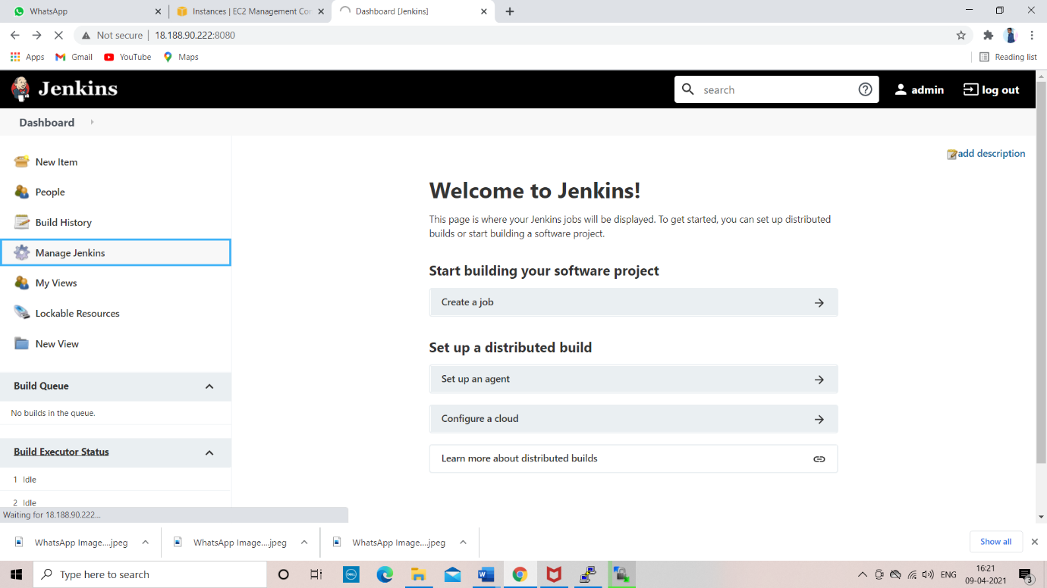

Go config system

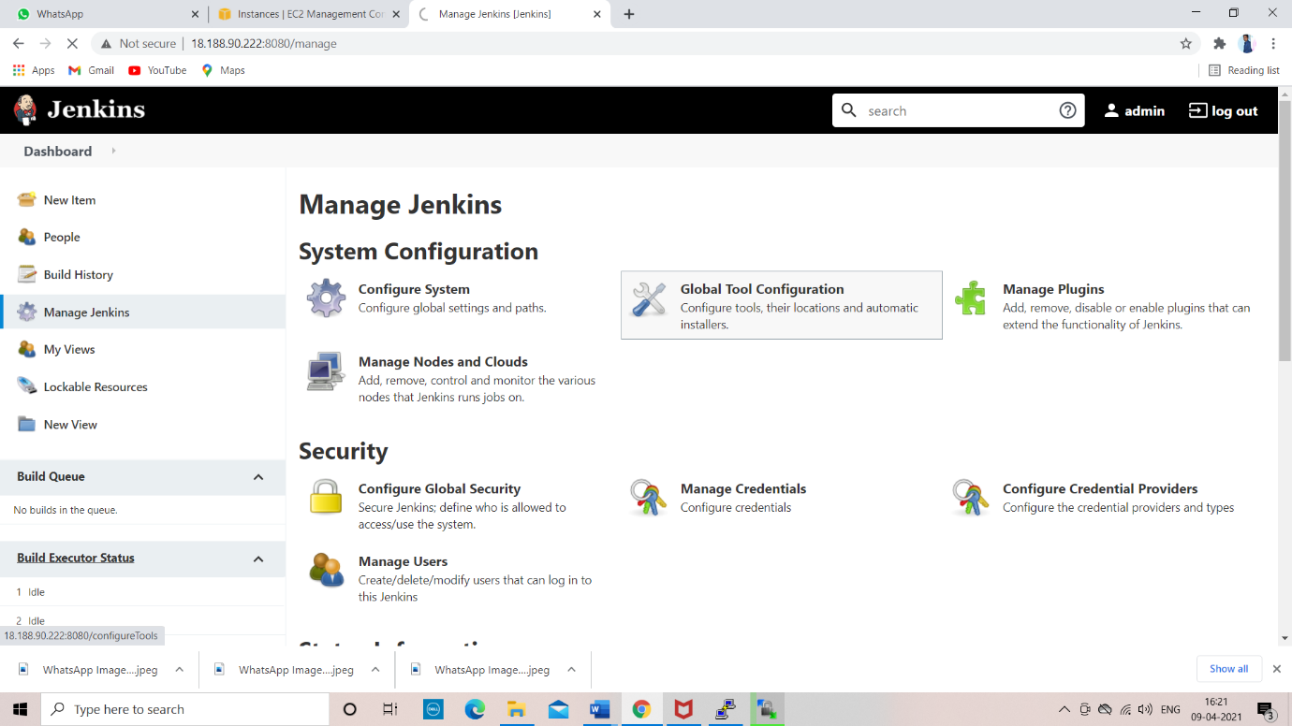

In configure system click on git server

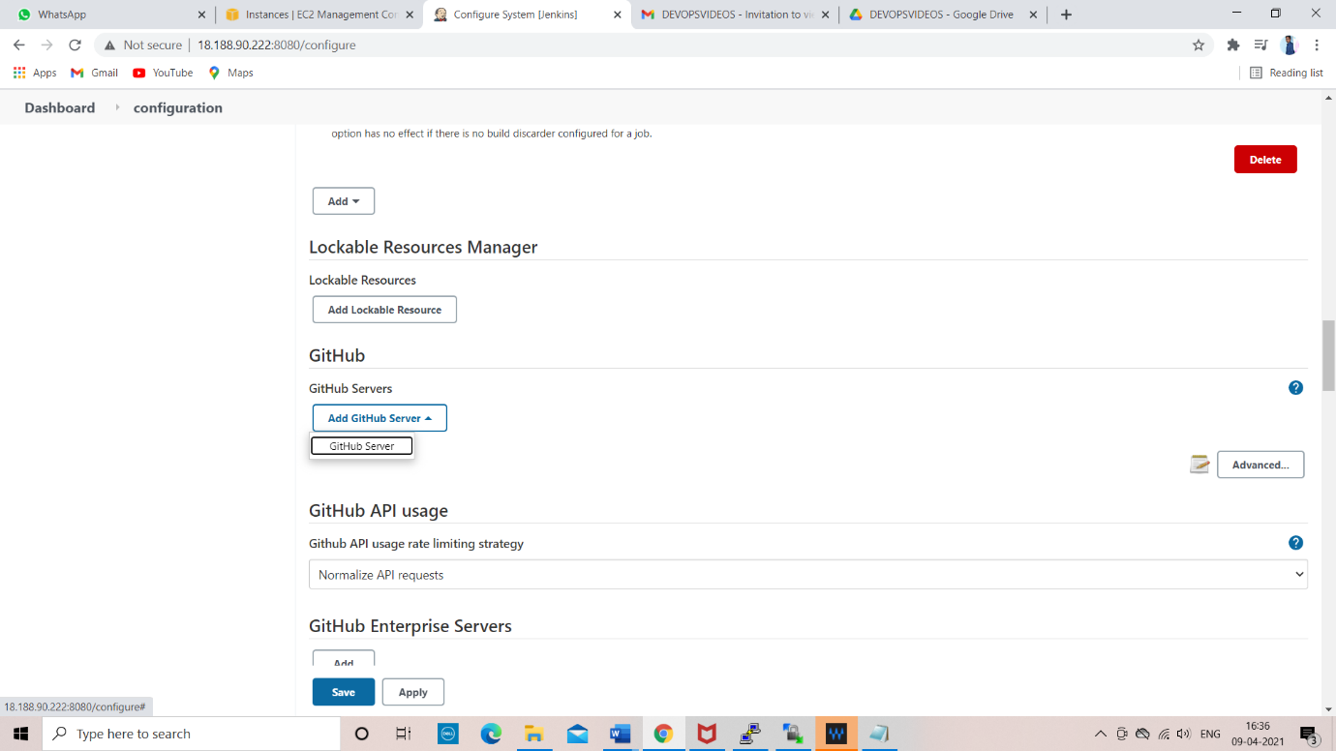

And provide your GitHub user name and password

Give your git hub URL

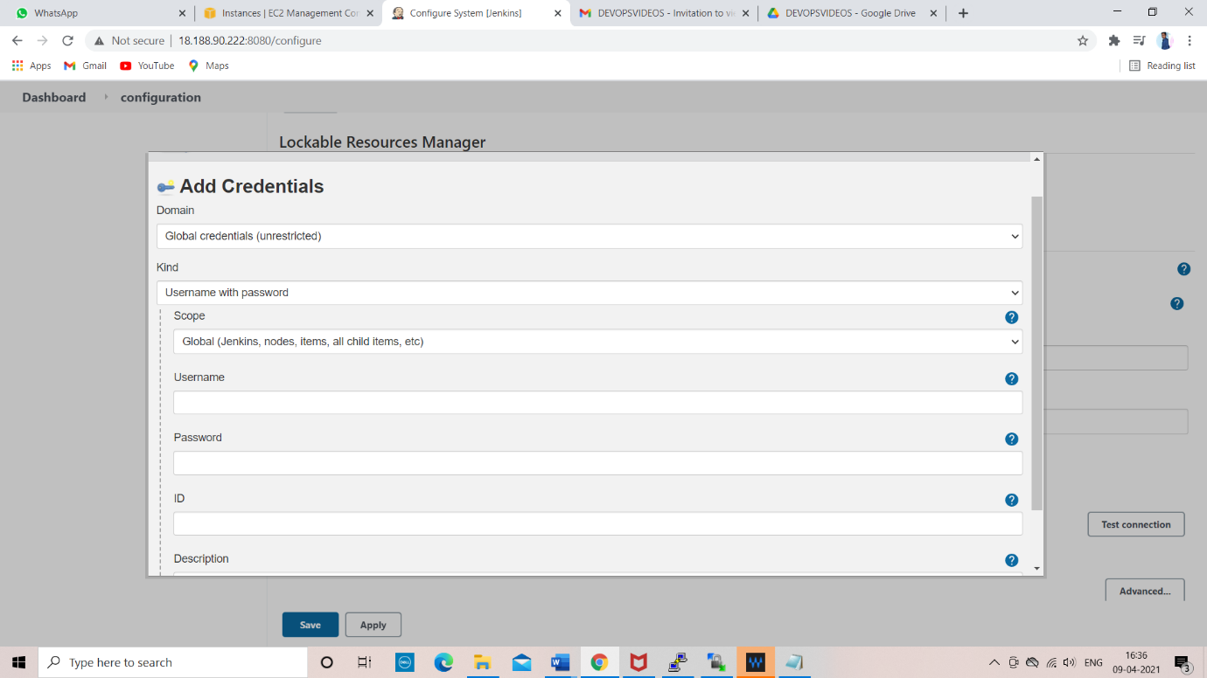

Step2

* we need to configure webhooks go to GitHub
* create a repository and go to settings
* in settings go to webhooks
* add web hooks enter your server IP address
* <http://ip/githu-webhook/>

click on add webhook

step 3

go to Jenkins

* In Jenkins create a new job

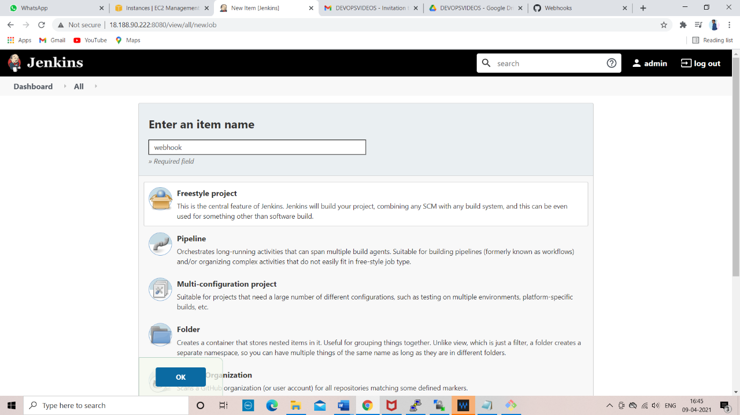

And go to git and provide your repository URL

Then go to build

Select execute shell

Finally click on save

After click on build than job will build automaticallay

When any changes will happen in git repository

Webhook will trigger the job automatically when any changes happened in the job

And go to git and provide your repository URL

Select

GitHub hook trigger for GITScm polling

And provide your git repository URL HERE

SAVE THE JOB

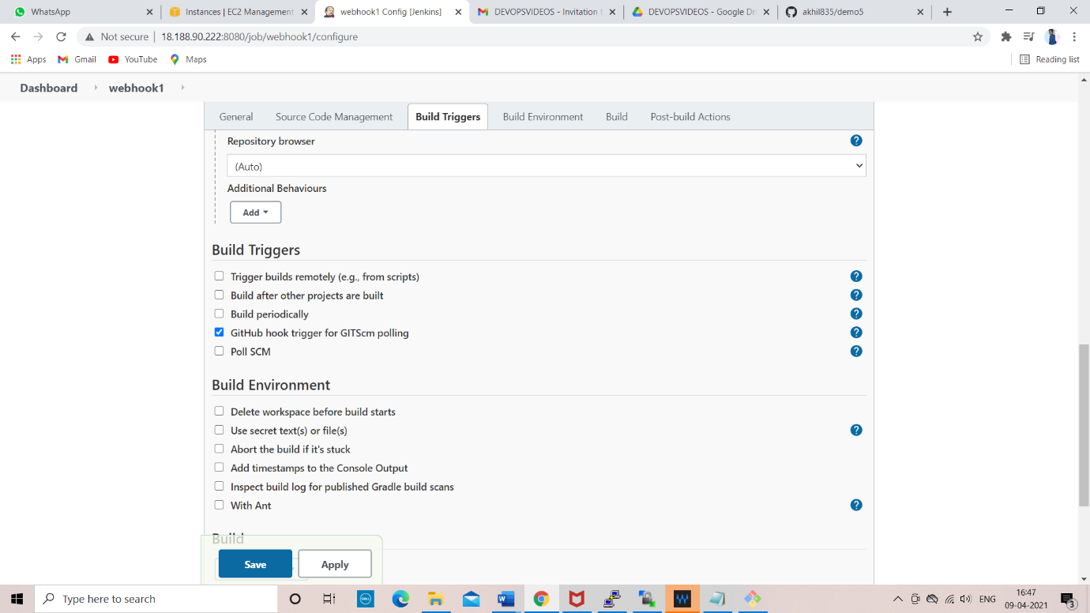

FINALLY BUILD THE JOB

If we made any changes in your job in git

In jenkins the job will automatically build

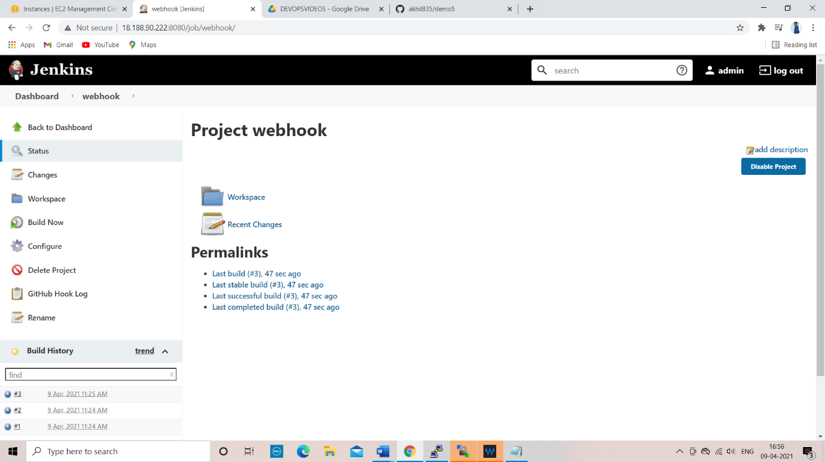

GIT POLLSCM

TO TRIGGER THE JOB BY TIME

NODES

NODES

why should we use remote system?

* jobs use your system resource much
* if you exceed the limit Jenkins server will be hang
* for that we are executing the jobs on the Jenkins we use remote system
* using remote system process will very fast and accurate
* server is highly available
* assume 100 jobs are running ex some are .net some are maven to run all of these we require software we cannot install all of these

we face some dependence issue

for example, here we are working on window job but our system is Linux

the job will fail

that why we use remote system run the windows job on windows system

STEP 1

Got to manage Jenkins in this select manage nodes

Create a new node

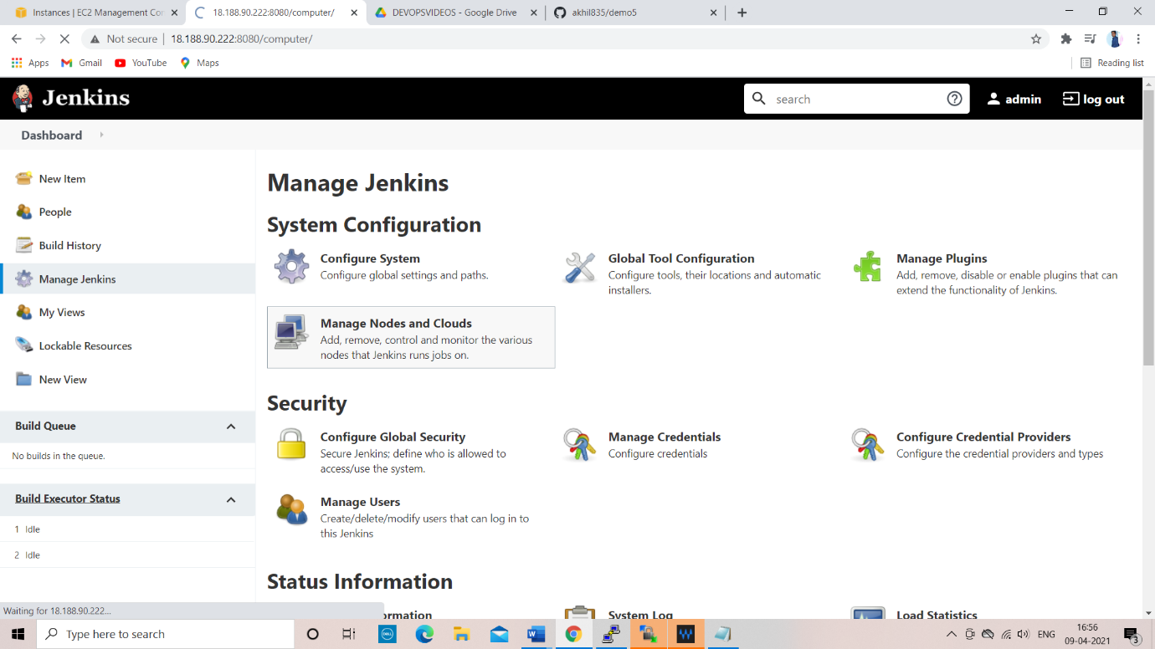

1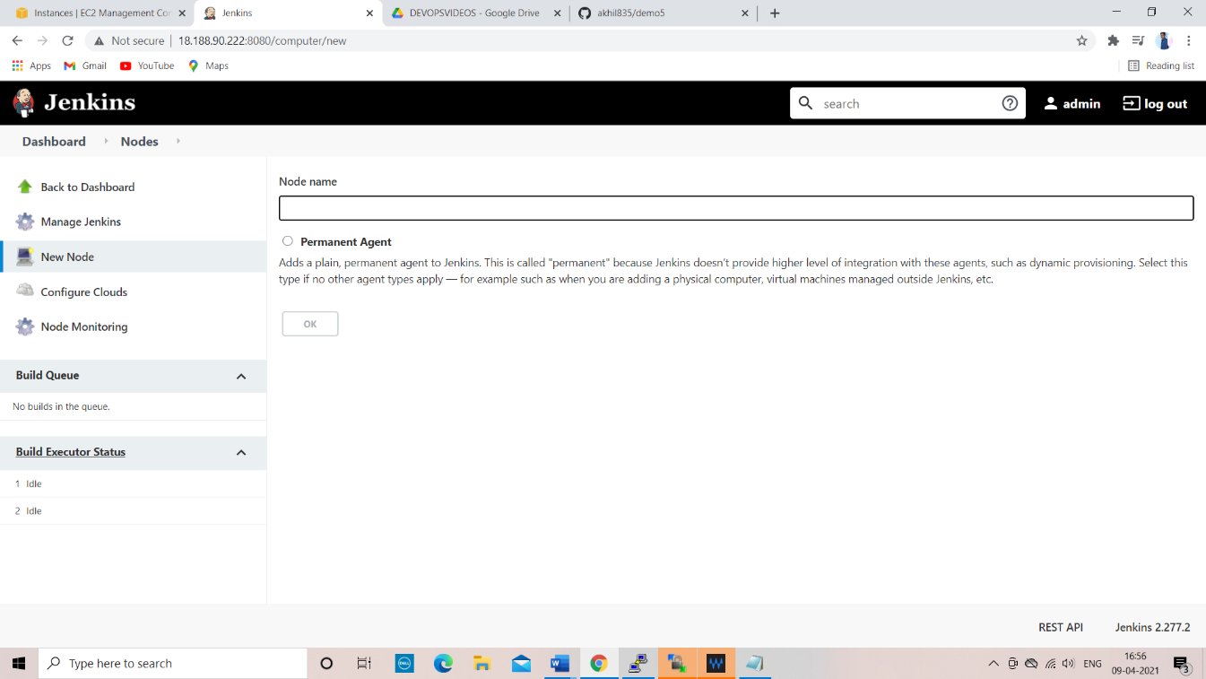

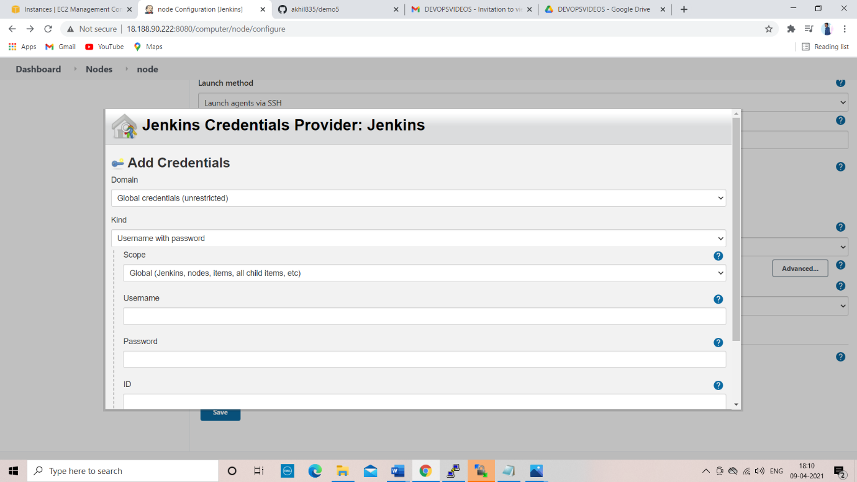

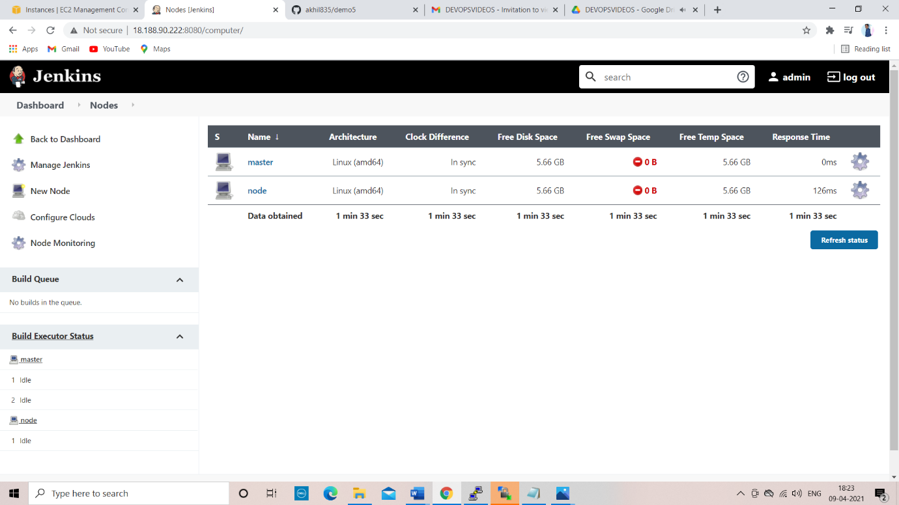

If you have two jobs

You can run one job on master and other job on nodes

If you click build automatically jobs will build on master and nodes

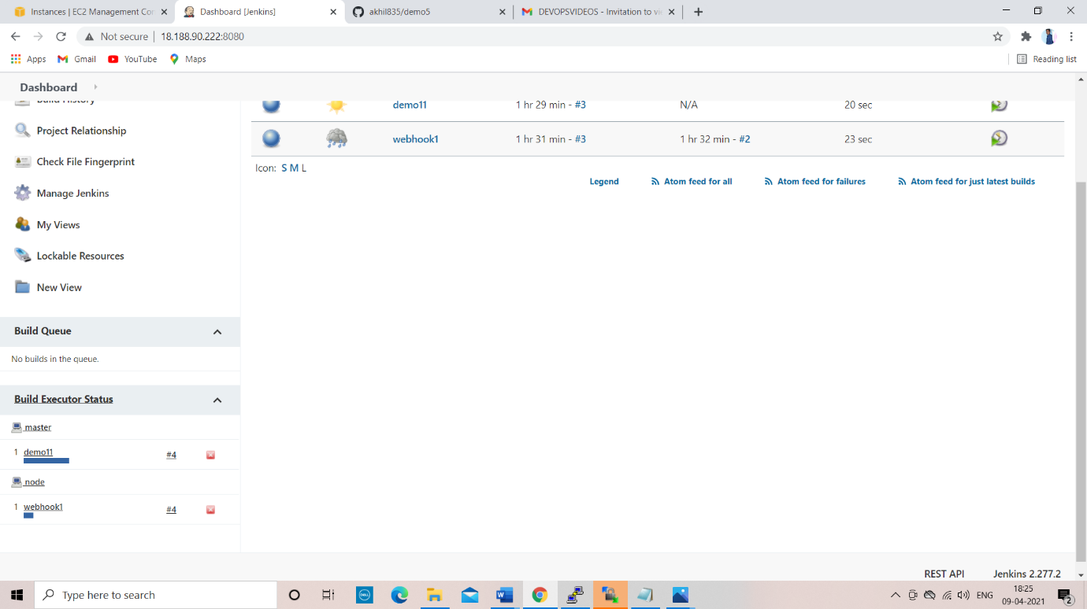

In master you also set execute one job at a time

If you set like this it will run one job at a time if you build a 2nd job it will build one remote system

You can also set the particular will run one specific system

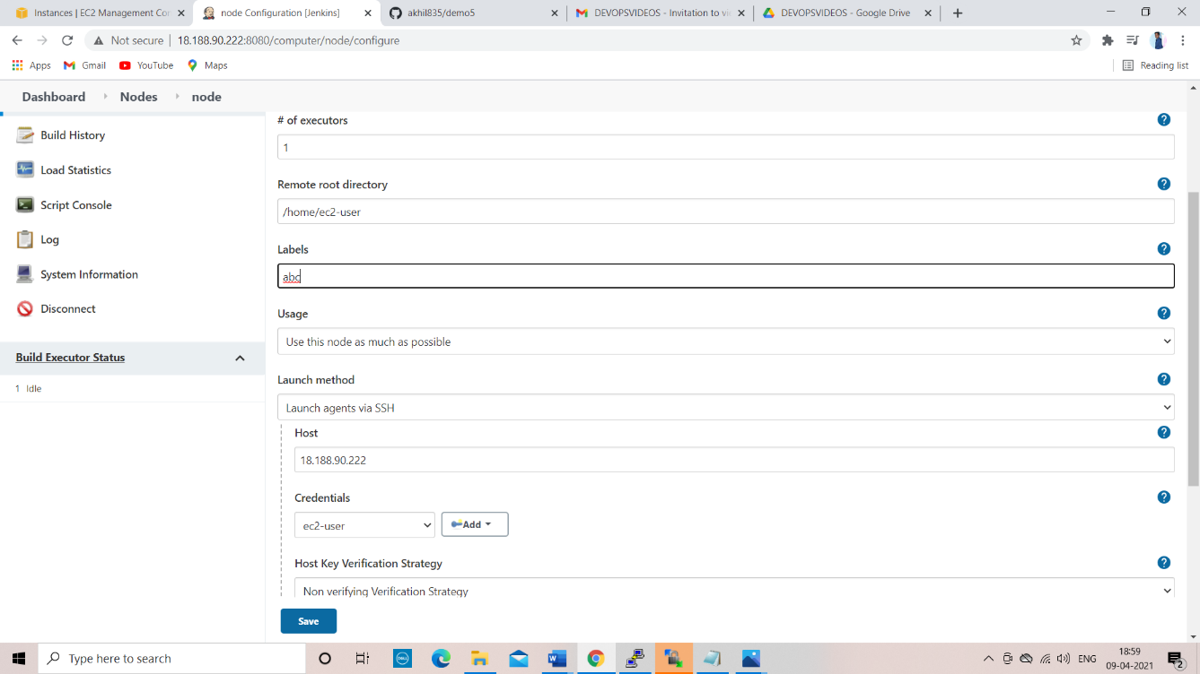

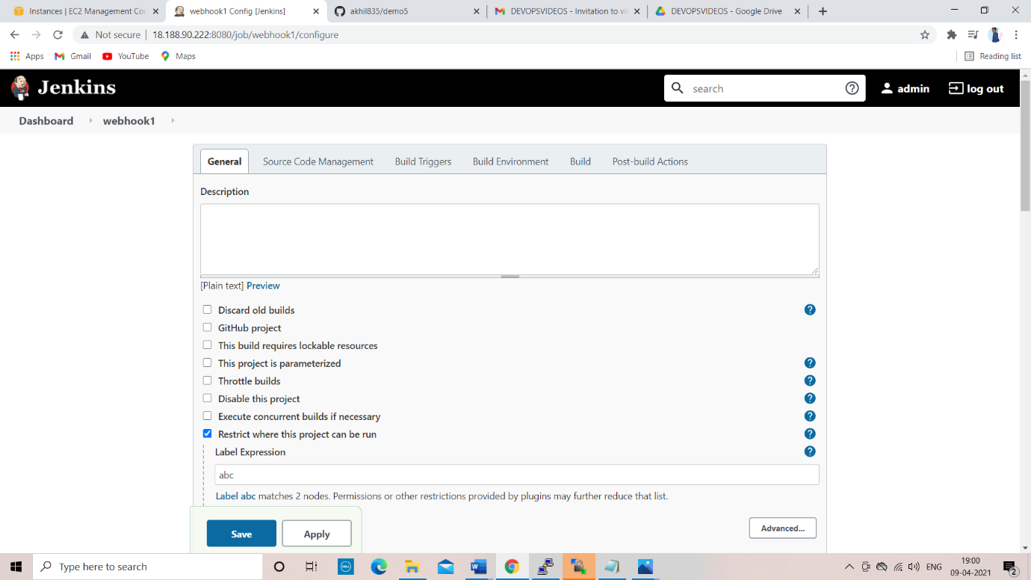

I will set demo11 will run node onely(remote system)

Even master was free when I build the demo11 it was build on node(remote system)

For example we want to build a windows job but our system is linux

Then we will create the node and build the job on the windows node

